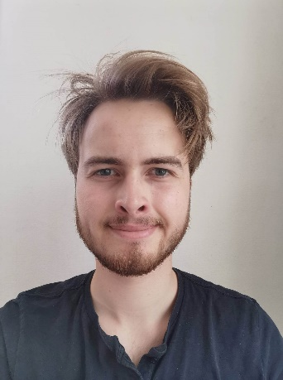**Summary**



**DTU Department of Bioengineering**

**Section for Microbial and Chemical Ecology**

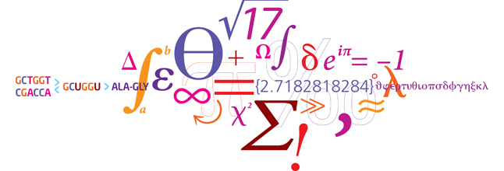

**Project Information**

**Student:** Lasse Schnell Danielsen

**Project type:** Bachelor project

**Location:** B-223, R-226 🡨

**Time span:** 01.03.23 – 05.06.2023

**Research group:** Bacterial Ecophysiology and

Biotechnology

**Supervisors:** Mikael Lenz Strube

**Analysis of rRNA multiplicity and diversity**

**Instructions**

1. Please do not change the font or font sizes
2. Please do not change the placement or sizes of text boxes
3. Save the file with the following name structure: “YEAR_SEMESTER_Student_name_A5-poster”

Example “*2017_fall_Homer_Simpson_A5-poster*”

1. Print/save the file in pdf format and check the layout
2. Upload in Online safety test

Bacteria have different numbers of 16S genes and different amounts of variability across their 16S genes. The objective of this project is to establish correlations between the variability and abundance of 16S genes and ecological factors. This will be done through datamining both databases and bacterial genomes for 16s gene information and ecological information.

File: *‘TEMPLATE A5 poster with project description (2017-03-02).doc’*

Rasmus Frandsen 2017